How to Pay Fees Online thru Parent Portal

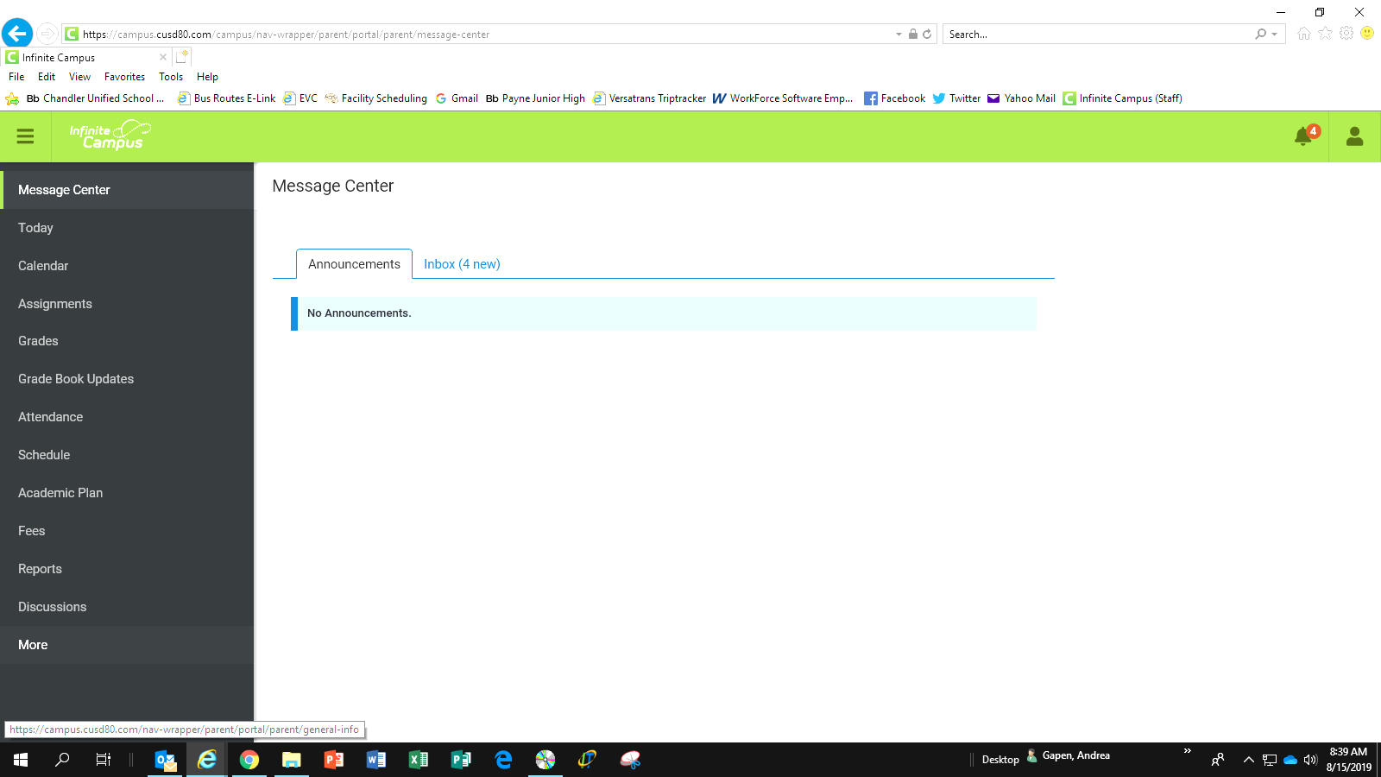

Log in to your Parent Portal. You do not need to select your student at this point.

Click on **More**

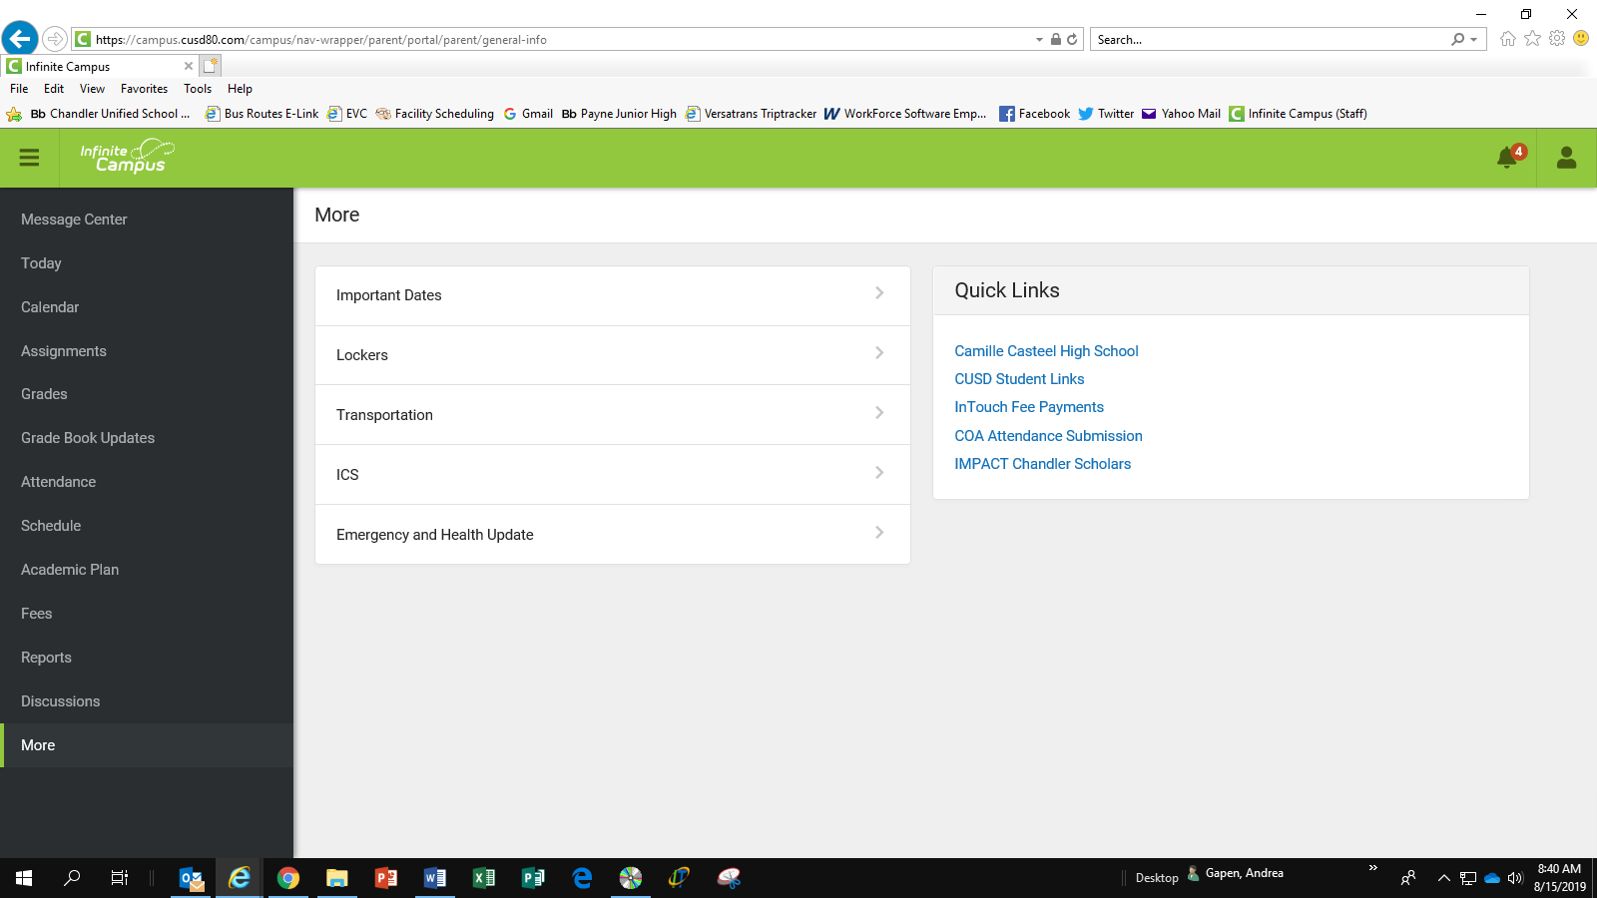

This is where you can complete the Emergency and Health Update AND make your

**InTouch Fee Payments.**

**DO NOT USE THIS LINK!**

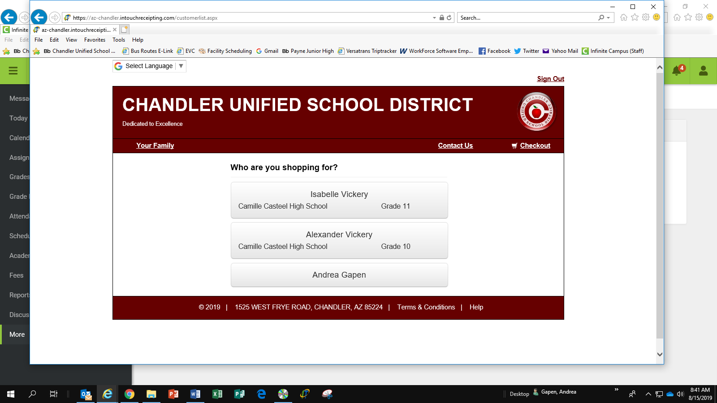

Click on your student

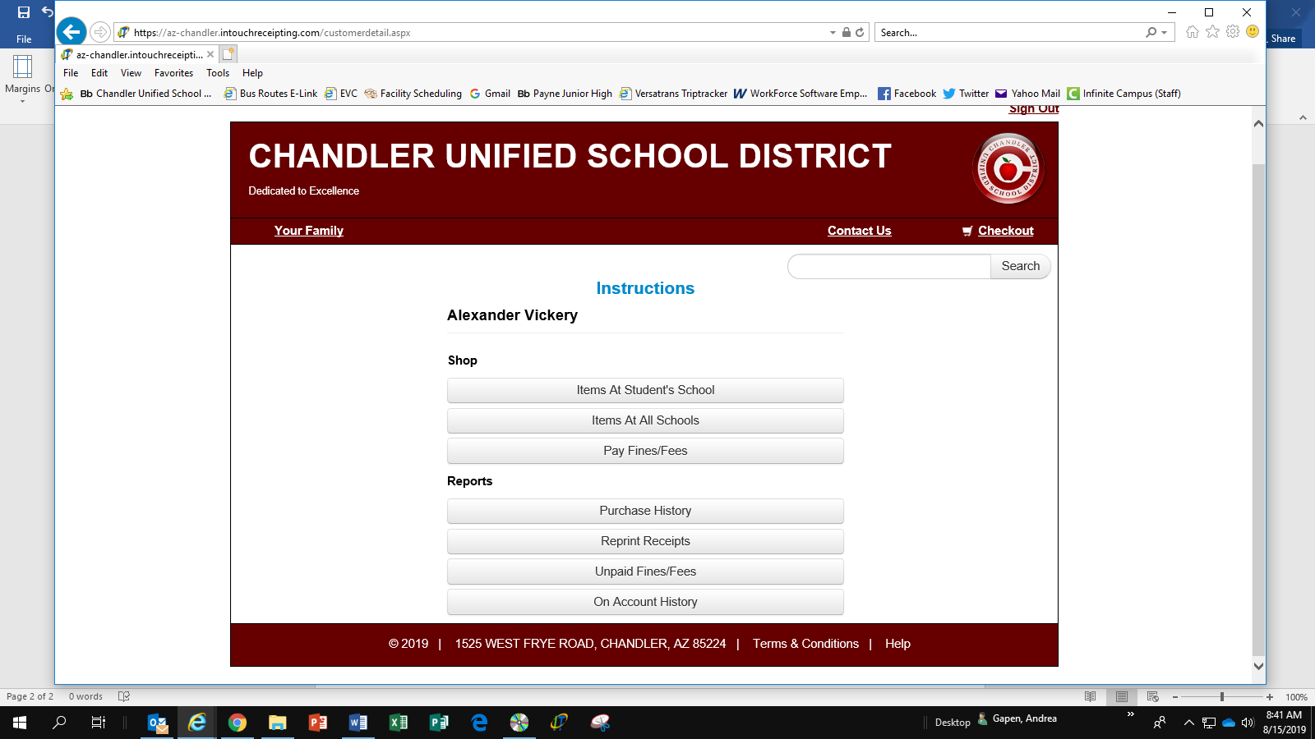

Click on **Pay Fines/Fees**

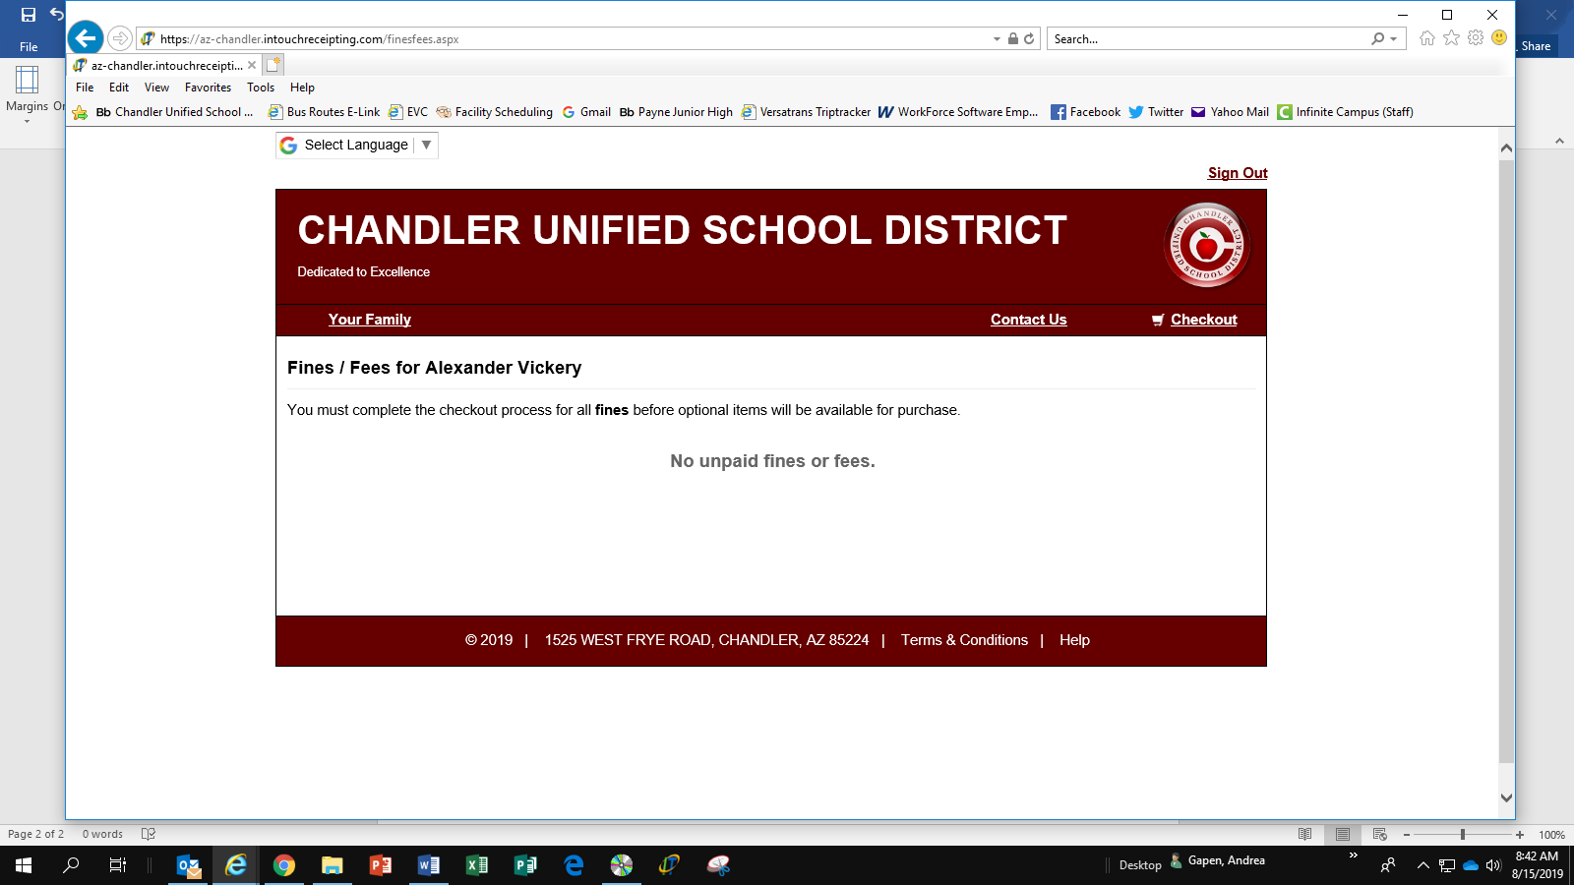

If your student has fees assigned, they will be listed here.